



Technical Design documentation

Document History

|  |  |  |  |
| --- | --- | --- | --- |
| Version | Updated By | Date | Comments |
| 1.1 | Vamshi Vushakola  Rohit John Alex |  | Initial Draft |
|  |  |  |  |
|  |  |  |  |

Document Sign-Off

|  |  |  |
| --- | --- | --- |
| Name | Role | Signature/Date |
| Gyaneshwar Dubey | Manager |  |
|  |  |  |
|  |  |  |

Table of Contents

1. Introduction 4

1.1 Purpose 4

1.2 Document Scope 4

1.3 Functional Rules 4

1.4 Assumptions/Restrictions 4

1.5 Documents Structure 5

1.6 Additional Resources 5

2. High Level Design Diagram 6

2.1 Sequence Diagram 6

2.2 Class Diagram: 7

2.3 Use Case Diagram: 8

3. Installation and Configuration 9

3.1 Hybris Commerce Suit Setup 9

3.2 To create a completely new storefront. 9

4. Customize Initialization Process - System Setup Classes 11

4.1 Data import across the accelerator extensions 11

4.2 Calling import of asianpaintsb2bcore and asianpaintsb2binitialdata data 12

5. Impex - Basic store data 13

5.1 Basic store data 13

5.2 Content Catalog Data 14

5.3 Product Catalog Data 14

5.4 CatalogVersion synchronization jobs 15

5.5 Run the project data initialization for the asianpaintsb2bcore extension 15

6. Impex - Create products 17

6.1 Implement product import bundle in initialization class 17

6.2 Import product categories 17

6.3 Import suppliers 17

6.4 Import products 17

6.5 Import product Medias: 17

6.6 Import product prices 18

6.7 Import stock levels 18

6.8 Assign warehouse to base store 18

6.9 Activating Solr index for the product content. 18

6.10 Add write permission for the productmanager user. 19

7. Impex - Site CMS Content 20

7.1 Import CMS data: 20

7.2 Import email content 20

7.3 Configuring cmsmanager 20

7.4 Localizing the store-frontend labels 20

7.5 Run project data update and review the store frontend 21

8. Additional Custom Features 23

8.1 Pick Up In Store 23

8.2 Vouchers 25

8.3 Custom Delivery Methods 26

8.4 Custom Promotions 27

1. Introduction

Purpose

This document is the Technical Design Document which provides information about asianpaintsb2b, which is a B2C e-commerce site and steps to configure the module.

Document Scope

This document covers the details about B2C e-commerce site.

Functional Rules

* Asianpaintsb2b site allows users to add products to cart and to place order.
* We added additional custom features like Pickup-in store, Vouchers, Promotions and own delivery methods.

Assumptions/Restrictions

* We kept restrictions on Vouchers, Where it can be redeemed only 100 times and not more than that.
* In promotions, we have given a threshold price value, Which should be achieved by the customer to get those promotions.

Documents Structure

|  |  |  |
| --- | --- | --- |
| Section | | Description |
| 1 | Introduction | Describes the purpose and intended audience of the document and explains its structure. |
| 2 | High Level Design | Overview of the module. |
| 3 | Installation & Configuration | Steps to install and configure the module. |
| 4 | Customize Initialization Process - System Setup Classes | One of the goals of the initialization process is to prepare the data for your store. |
| 5 | Impex - Basic store data | We will provide impex files for the basic asianpaintsb2b store data. |
| 6 | Impex - Create products | In this we will import our asianpaintsb2b store products and synchronize them to the online catalog. |
| 7 | Impex - Site CMS Content | In this we add cms-content related information. |
| 8 | Additional Custom Features | We mentioned all the custom features that we have added. |

Additional Resources

|  |  |  |  |
| --- | --- | --- | --- |
| # | Description | URL | Purpose |
| 1 | Hybris Wiki | <https://wiki.hybris.com> | For more information on we can refer hybris wiki to understand the modules used in this assets |

1. High Level Design Diagram

Sequence Diagram

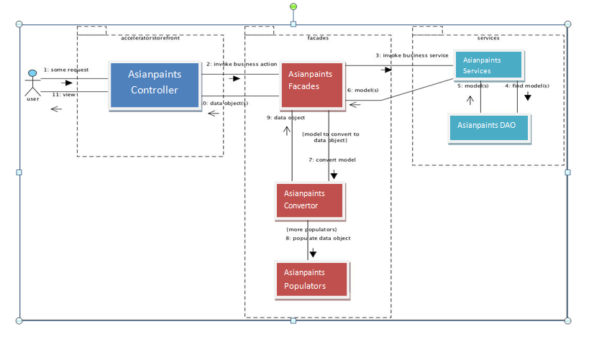

Fig: Sequence diagram

Description:

|  |  |  |
| --- | --- | --- |
| **#** | **Component** | **Description** |
| **1** | **Controller** | It will get request from user and data from the form will be given to façade. And in return, it will get the data objects from façade and it gets displayed on UI. |
| **2** | **Facade** | It will get the data objects from controller and convert it to model object. This object is passed to service layer for further processing and vice-versa. |
| **3** | **Service** | It will passes model objects, which is received from façade layer to DAO Layer and vice-versa. |
| **4** | **DAO** | Search in the database products by a code entered by the B2C customer/user. |

## 

Class Diagram:

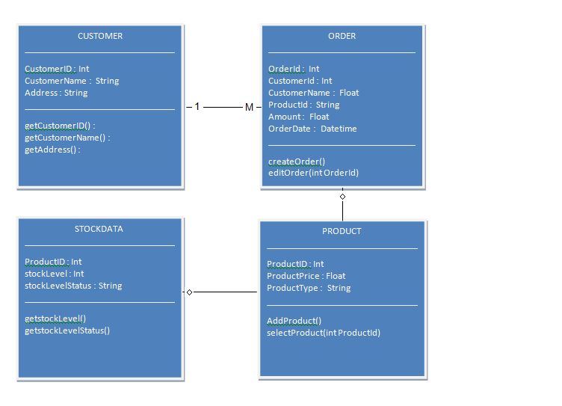

Use Case Diagram:

Order

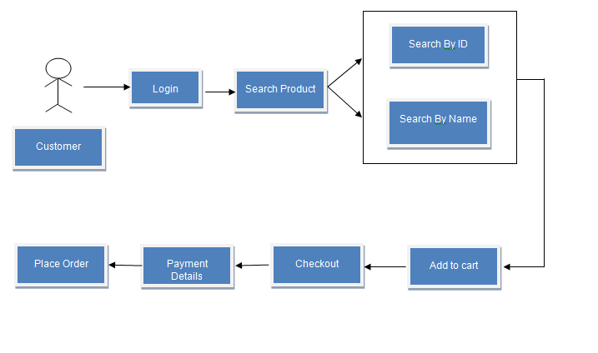

1. Installation and Configuration

## Hybris Commerce Suit Setup

1. Download and install the hybris Commerce Suit Version 5.7.0.5 from

<https://wiki.hybris.com/display.downloads/Download>

1. Installing the hybris Commerce Suite
2. Extract the ZIP to a new or empty new or empty directory of your choice. If you're using Windows, please use a directory close to the root, and don't use directories with spaces in their names.
3. Change to the hybris/bin/platform directory.
4. Run the setantenv.bat and then do ant clean all
5. Once ant clean all has completed successfully, initialize your system from Hybris Administration Console ( <http://localhost:9001>).
6. After initialization, Check Default Electronics Store by using following URL:

<https://localhost:9002/yacceleratorstorefront/?site=electronics>

(OR)

<https://electronics.local:9002/yacceleratorstorefront/?site=electronics>

## To create a completely new storefront.

1. Create the accelerator code base for the project.
2. Stop the server.  Run 'modulegen' task from your platform build.xml: **ant modulegen**

|  |
| --- |
| **modulegen:**  [input]  [input] Please choose a template for generation.  [input] Press [Enter] to use the default value ([accelerator], b2baccelerator, telcoaccelerator, commercewebservices)  **accelerator**  [input]  [input] Please choose the name of your module extension. It has to start with a letter followed by letters and/or numbers.  [input] Press [Enter] to use the default value [training]  **asianpaintsb2b**  [input]  [input] Please choose the base package name of your extensions. It has to fulfill java package name convention. Each extension in the module will add its name to this package.  [input] Press [Enter] to use the default value [org.training]  **com.asianpaintsb2b** |

1. After this step you should have 7 custom extensions in custom folder that have been adopted to your project's namespace.

* /custom/asianpaintsb2b/asianpaintsb2bcockpits
* /custom/asianpaintsb2b/asianpaintsb2bcore
* /custom/asianpaintsb2b/asianpaintsb2bfacades
* /custom/asianpaintsb2b/asianpaintsb2bfulfilmentprocess
* /custom/asianpaintsb2b/asianpaintsb2binitialdata
* /custom/asianpaintsb2b/asianpaintsb2bstorefront
* /custom/asianpaintsb2b/asianpaintsb2btest

1. Now edit local extensions.xml by commenting **yaccelerator** extensions

<!-- <extension name='yacceleratorcockpits' /> -->

<!-- <extension name='yacceleratorinitialdata' /> -->

<!-- <extension name='yacceleratorfulfilmentprocess' /> -->

<!-- <extension name='yacceleratorstorefront' /> -->

1. Now add these extensions in custom folder

<extension name='asianpaintsb2bcockpits' />

<extension name='asianpaintsb2bcore' />

<extension name='asianpaintsb2bfacades’/>

<extension name='asianpaintsb2bfulfilmentprocess' />

<extension name='asianpaintsb2binitialdata'/>

<extension name='asianpaintsb2bstorefront'/>

<extension name='asianpaintsb2btest'/>

1. Now Initialize system from platform directory: **ant initialize**
2. Now Start Hybris Server from platform directory: **hybrisserver.bat.**
3. Now Check Default Asianpaintsb2b Store by using this following URL:

[https://localhost:9002/asianpaintsb2bstorefront/?site=asianpaintsb2b](https://localhost:9002/asianpaintsstorefront/?site=asianpaints)

1. Eclipse Configuration

* Set-up a new Eclipse workspace and import all the extensions mentioned in localextensions.xml as well as the **platform** extension and **config** directory (remember that it's located one level up from the extensions).
* Verify this following tag in asianpaintsb2bstorefront/extensioninfo.xml file

|  |
| --- |
| asianpaintsb2bstorefront/extensioninfo.xml  <webmodule jspcompile="false" webroot="/asianpaintsb2bstorefront/”> |

* Now rebuild the code base by doing **ant clean all** and restart the **hybris server**.
* And navigate to  <http://localhost:9001> then Platform -> Update and do an **project data update** on **asianpaintsb2bcore** extension.

1. Customize Initialization Process - System Setup Classes

One of the goals of the initialization process is to prepare the data for your store. The accelerator provides two dedicated initialization hooks that allow you to import your custom data.

1. Core data hook - in our namespace that is the **CoreSystemSetup** class in asianpaintsb2bcore extension
2. Sample data hook - in our namespace that is the **InitialDataSystemSetup** class in asianpaintsb2binitialdata extension.

## Data import across the accelerator extensions

1. Asianpaintsb2b core initialization hook

* By design it is meant to initialize the store's basic data: cockpit definitions, email templates, CMS layout, etc.

1. Asianpaintsb2b sample data initialization hook

* By design this is meant to be the hook for all the product and concrete cms-content initializations. All store-specific data should be defined here: catalogs, Solr configurations, etc.
* This hook uses import services **CoreDataImportService** and **SampleDataImportService** to import the appropriate data.

1. Asianpaintsb2b core data import service

* By design this is meant to provide the Asianpaintsb2b Sample Data hook an easy way to import all essential core data for a new store. This service is used to import basic structure of a store (i.e.: catalog definition, email templates, site definition)

1. Sample data import service

* By design this is meant to provide the Asianpaintsb2b Sample Data hook an easy way to import all the store-specific data and fill the structure defined by Asianpaintsb2b Core Data Import Service with concrete data (i.e.: product data, images).

1. Modify CoreSystemSetup to include our new shop's basic data during project data initialization.

|  |
| --- |
| **hybris\bin\custom\asianpaintsb2b\asianpaintsb2binitialdata\src\com\asianpaintsb2b\core\setup\CoreSystemSetup.java** |

1. Modify InitialDataSystemSetup to include our products, cms-content during project data initialization.

|  |
| --- |
| **hybris\bin\custom\asianpaintsb2b\asianpaintsb2binitialdata\src\com\asianpaintsb2b\initialdata\setup\InitialDataSystemSetup.java** |

## Calling import of asianpaintsb2bcore and asianpaintsb2binitialdata data

* Build the code base and restart the hybris server.
* Go to the system update in the hybris administration console (hac).
* To import our project data, you need to tick two checkboxes in the project data section (asianpaintsb2bcore and asianpaintsb2binitialdata).

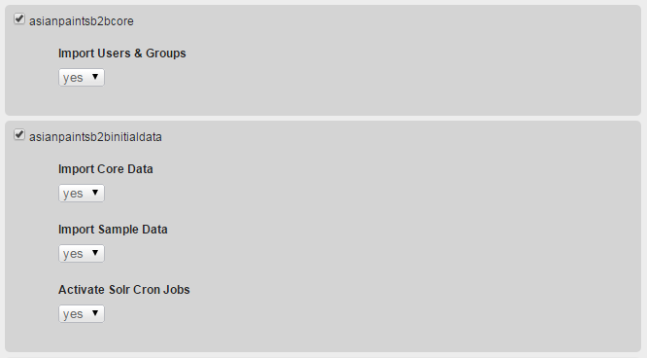

1. Impex - Basic store data

In this we will provide impex files for the basic asianpaintsb2b store data. The data is imported by **CoreSystemSetup** using an initialization hook.

Rename the project folders like below for **coredata** as well as **sampledata.**

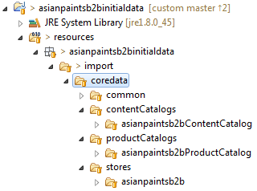 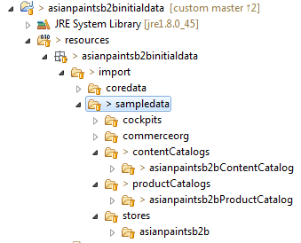

## Basic store data

In store.impex you must add new macro:

$storePrefix=asianpaintsb2b

And replace:

__PRODUCT_CATALOG_NAME__ with $storePrefixProductCatalog

__STORE_UID__ with $storePrefix

__DEFAULT_PROMO_GRP__ with asianpaintsb2bPromoGrp

**store.impex:** We should also add some delivery (shipping) methods to this impex file.

|  |
| --- |
| **asianpaintsb2binitialdata\resources\asianpaintsb2binitialdata\import\coredata\stores\asianpaintsb2b\store.impex** |

**store-en.impex:** This file adds English localized attribute values for the basic store items.

|  |
| --- |
| **asianpaintsb2binitialdata\resources\asianpaintsb2binitialdata\import\coredata\stores\asianpaintsb2b\store_en.impex** |

**site.impex:** This file adds basic site information to the configuration of the hybris shop - again you need to

Substitute several macros in the same way as in above store.impex file - please replace the

Site.impex with the following content:

|  |
| --- |
| **asianpaintsb2binitialdata\resources\asianpaintsb2binitialdata\import\coredata\stores\asianpaintsb2b\site.impex** |

**site_en.impex:** Provide English-language localization for the asianpaintsb2b CMSSite.

|  |
| --- |
| **asianpaintsb2binitialdata\resources\asianpaintsb2binitialdata\import\coredata\stores\asianpaintsb2b\site_en.impex** |

**solr.impex:** Update the basic solr configuration, including information for ranges, facets, index names, etc.

|  |
| --- |
| **asianpaintsb2binitialdata\resources\asianpaintsb2binitialdata\import\coredata\stores\asianpaintsb2b\solr.impex** |

**solr_en.impex:** Now update the Solr localization.

|  |
| --- |
| **asianpaintsb2binitialdata\resources\asianpaintsb2binitialdata\import\coredata\stores\asianpaintsb2b\solr_en.impex** |

**solrtrigger.impex:** Update Solr indexing triggers.

|  |
| --- |
| **asianpaintsb2binitialdata\resources\asianpaintsb2binitialdata\import\coredata\stores\asianpaintsb2b\solrtrigger.impex** |

## Content Catalog Data

**catalog.impex:** The cmsmanagergroup will be allowed to perform modification of these catalogs in

cmscockpit.

|  |
| --- |
| **asianpaintsb2binitialdata/resources/asianpaintsb2binitialdata/import/coredata/ContentCatalogs/asianpaintsb2bContentCatalog/catalog.impex** |

**cms-content.impex:** Now the Master CMS content, which defines all of the content slots for the templates,

Naming the templates. It does not rely on any specific product/category content.

|  |
| --- |
| **asianpaintsb2binitialdata/resources/asianpaintsb2binitialdata/import/coredata/ContentCatalogs/asianpaintsb2bContentCatalog/cms-content.impex** |

**cms-content_en.impex:** Now the related localized attributes values - again check the file content and

Replace __CONTENT_CATALOG_NAME__ with asianpaintsb2bContentCatalog in the below file.

|  |
| --- |
| **asianpaintsb2binitialdata/resources/asianpaintsb2binitialdata/import/coredata/ContentCatalogs/asianpaintsb2bContentCatalog/cms-content_en.impex** |

## Product Catalog Data

**catalog.impex:**

|  |
| --- |
| **asianpaintsb2binitialdata/resources/asianpaintsb2binitialdata/import/coredata/ProductCatalogs/asianpaintsb2bProductCatalog/catalog.impex** |

**catalog_en.impex:**

|  |
| --- |
| **asianpaintsb2binitialdata/resources/asianpaintsb2binitialdata/import/coredata/ProductCatalogs/asianpaintsb2bProductCatalog/catalog_en.impex** |

## CatalogVersion synchronization jobs

Notice that the **createProjectData()** method includes code that creates cron jobs to synchronize catalog versions. These jobs target our new catalog versions (content and product) and can be run at any time to synchronize CMS content and products from their staged to online versions.

## Run the project data initialization for the asianpaintsb2bcore extension

Run **ant all**.

Update the project data of the asianpaintsb2bcore extension by selecting Import Core Data and Activate Solr Cron Jobs:

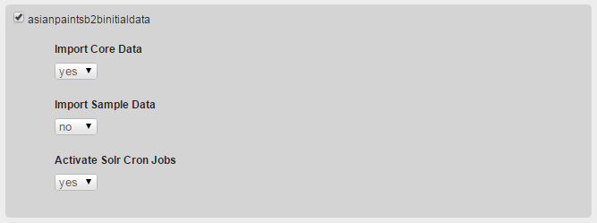

Once you have imported the data, you can go to the [hmc](http://localhost:9001/hmc/hybris) and look in the Base Commerce section that we have a new store called **asianpaintsb2b** and it has a website assigned with the same name. Like following way.

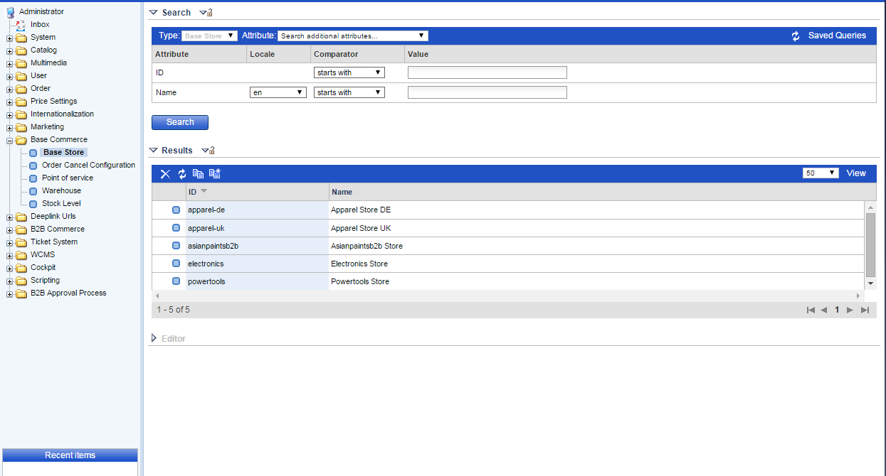

1. Impex - Create products

## Implement product import bundle in initialization class

The product data needs to be imported in InitialDataSystemSetup class.

We use these options to import our asianpaintsb2b store products and synchronize them to the online catalog.

## Import product categories

**categories.impex:** Imports Categories for your products

|  |
| --- |
| **asianpaintsb2binitialdata/resources/asianpaintsb2binitialdata/import/sampledata/productCatalogs/asianpaintsb2bProductCatalogs/categories.impex.** |

**categories_en.impex:** Imports localized names for categories.

|  |
| --- |
| **asianpaintsb2binitialdata/resources/asianpaintsb2binitialdata/import/sampledata/productCatalogs/asianpaintsb2bProductCatalogs/categories_en.impex** |

## Import suppliers

**suppliers.impex**: Imports store's suppliers.

|  |
| --- |
| **asianpaintsb2binitialdata/resources/asianpaintsb2binitialdata/import/sampledata/productCatalogs/asianpaintsb2bProductCatalog/suppliers.impex** |

## Import products

**products.impex:** Imports products available from the Asianpaintsb2b store.

|  |
| --- |
| **asianpaintsb2binitialdata/resources/asianpaintsb2binitialdata/import/sampledata/productCatalogs/asianpaintsb2bProductCatalog/products.impex** |

## Import product Medias:

**products-media.impex:**

|  |
| --- |
| **asianpaintsb2binitialdata/resources/asianpaintsb2binitialdata/import/sampledata/productCatalogs/asianpaintsb2bProductCatalog/products-media.impex** |

**products_en.impex:** Imports localized attributes of the products

|  |
| --- |
| **asianpaintsb2binitialdata/resources/asianpaintsb2binitialdata/import/sampledata/productCatalogs/asianpaintsb2bProductCatalog/products_en.impex** |

## Import product prices

**products-prices.impex:** Imports prices of the products

|  |
| --- |
| **asianpaintsb2binitialdata/resources/asianpaintsb2binitialdata/import/sampledata/productCatalogs/asianpaintsb2bProductCatalog/products_prices.impex** |

## Import stock levels

**products-stocklevels.impex:** Imports warehouse stocklevels for the products

|  |
| --- |
| asianpaintsb2binitialdata/resources/asianpaintsb2binitialdata/import/sampledata/productCatalogs/asianpaintsb2bProductCatalog/ products-stocklevels.impex |

## 

## Assign warehouse to base store

Navigate to the sampledata/stores/asianpaintsb2b directory, and assign a warehouse to the base store:

**warehouses.impex:**

|  |
| --- |
| **asianpaintsb2binitialdata/resources/asianpaintsb2binitialdata/import/sampledata/stores/asianpaintsb2b/warehouse.impex** |

## Activating Solr index for the product content.

* Accelerator indexes categories names in a way that it requires additional dedicated spring beans for resolving category names, codes per each configured store.
* Add the following beans definitions:

**asianpaintsb2bcore-spring.xml:** Accelerator requires additional beans for resolving category names, as accelerator indexes category names.

|  |
| --- |
| **asianpaintsb2bcore/resources/asianpaintsb2bcore-spring.xml** |

## Add write permission for the productmanager user.

**cmscockpit-users.impex:** As we added new product catalog version should add write permission for the default productcockpit user.

|  |
| --- |
| **asianpaintsb2binitialdata/resources/asianpaintsb2binitialdata/import/sampledata/cockpit/cmscockpit-users.impex** |

Trigger Project data update and review product cockpit:

1. Restart the server
2. Go to the admin console and run project data update for asianapintsinitialdata.

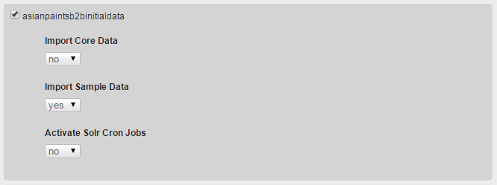

Having initialized the data, go and visit [productcockpit](http://hybris.local:9001/productcockpit/) to review newly created products:

1. Impex - Site CMS Content

## Import CMS data:

### cms-content.impex: Real CMS content for the Asian Paint site.

|  |
| --- |
| **asianpaintsb2binitialdata/import/sampledata/contentCatalogs/asianpaintsb2bContentCatalog/cms-content.impex** |

**cms-content_en.impex:** Localized CMS content.

|  |
| --- |
| **asianpaintsb2binitialdata/import/sampledata/contentCatalogs/asianpaintsb2bContentCatalog/cms-content_en.impex** |

## Import email content

**email-content.impex:** This ImpEx is for Importing Email Content into Asianpaintsb2b store

|  |
| --- |
| **asianpaintsb2binitialdata/import/sampledata/contentCatalogs/asianpaintsb2bContentCatalog/email-content.impex** |

**email-content_en.impex:** Localized email content for english.

|  |
| --- |
| **asianpaintsb2binitialdata/import/sampledata/contentCatalogs/asianpaintsb2bContentCatalog/email-content_en.impex** |

## Configuring cmsmanager

**cmscockpit-users.impex:** This file imports sample cms cockpit user.

|  |
| --- |
| **asianpaintsb2binitialdata/import/sampledata/contentCatalogs/asianpaintsb2bContentCatalog/email-content_en.impex** |

## Localizing the store-frontend labels

**site-asianpaintsb2b.properties**

|  |
| --- |
| **asianpaintsb2bstorefront/web/webroot/WEB-INF/messages/site-asianpaintsb2b.properties** |

## Run project data update and review the store frontend

Update by selecting only Import Sample Data



After a successful update, restart the server and visit our [asianpaintsb2b store](http://hybris.local:9001/store/).

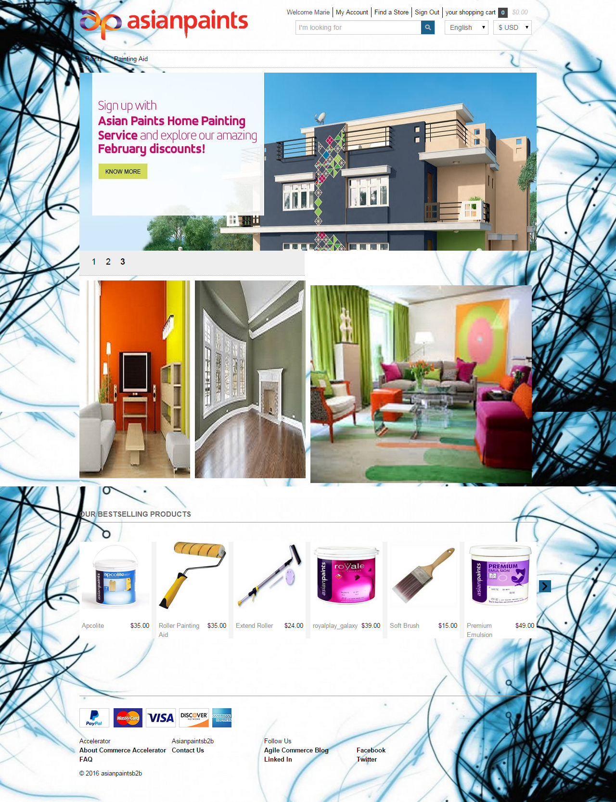

**Product details page:**

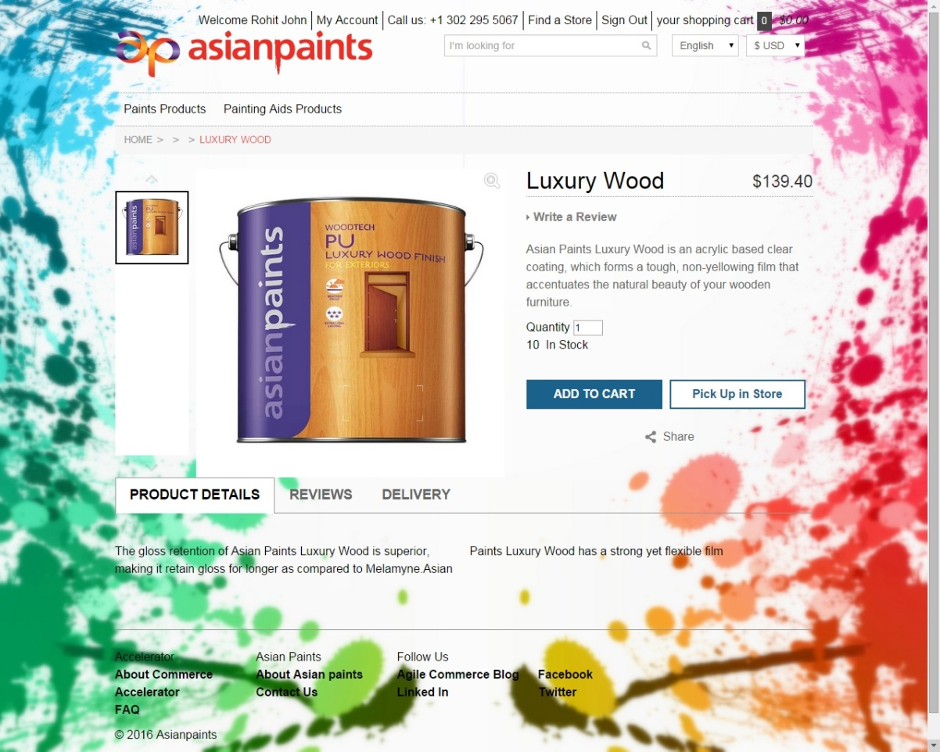

**Store lookup and availability:**

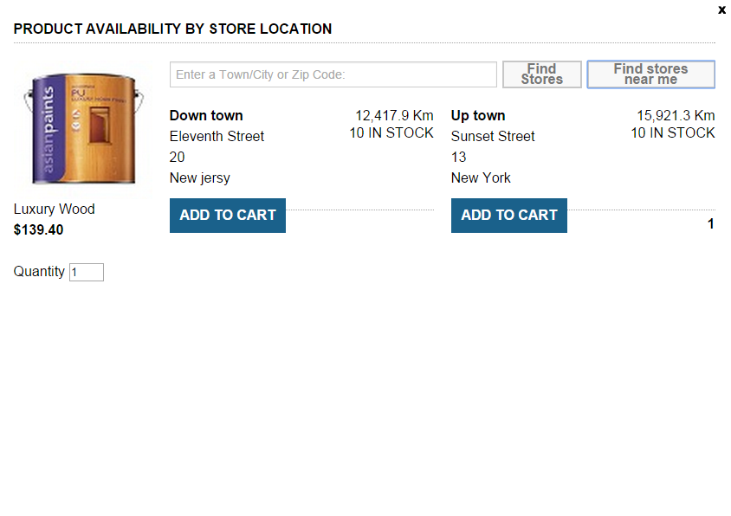

**Product Listing Page**

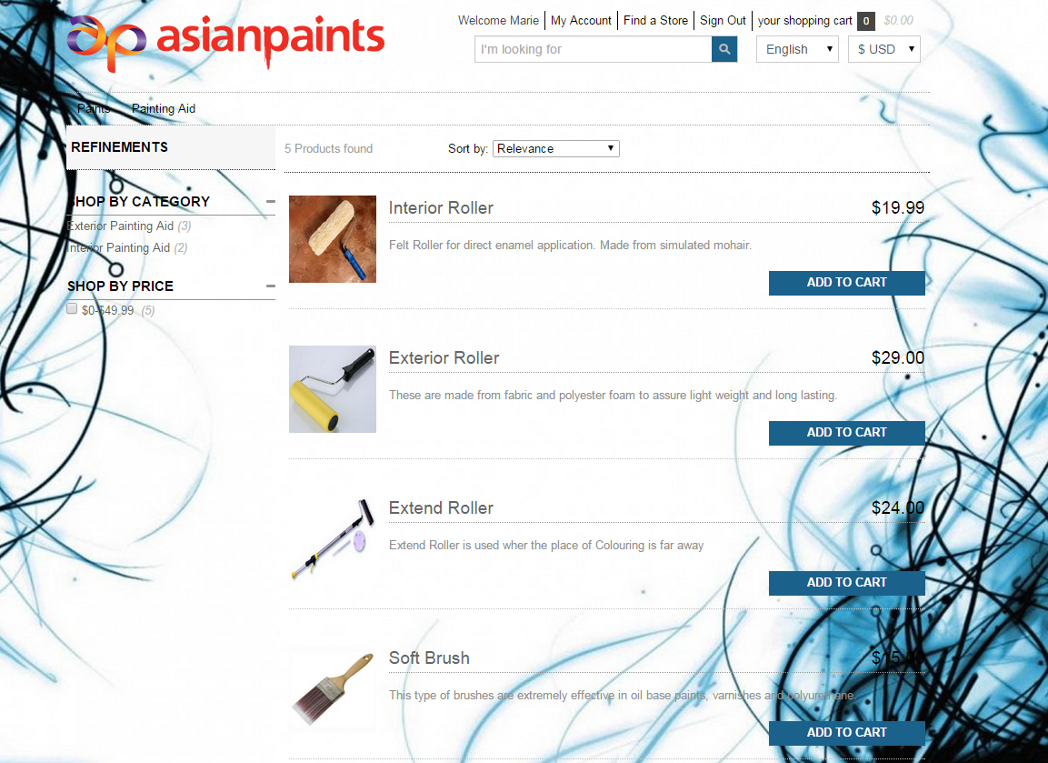

|  |
| --- |
| This Zip file contains all Impexes, Java Classes, xml files and properties file. |
|  |